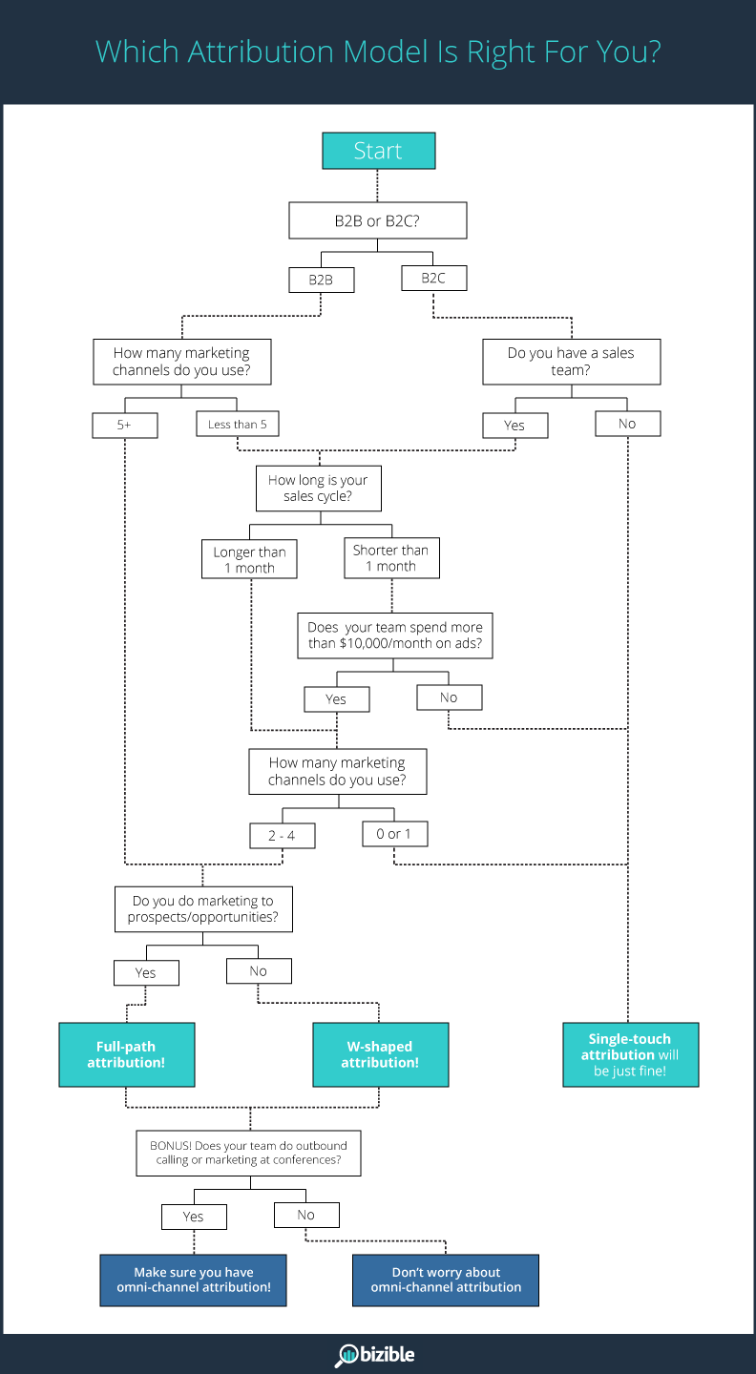

For Markov model

<https://www.youtube.com/watch?v=M_IIW0VYMEA>

Multi touch attribution model material

<http://www.bizible.com/blog/multi-touch-attribution-full-debrief>

<https://support.google.com/analytics/answer/1662518?hl=en>

<http://analyzecore.com/2016/08/03/attribution-model-r-part-1/>

Case study

<https://www.slideshare.net/iclick_interactive/attribution-modeling-case-study>

<https://www.slideshare.net/AspaLekka/advanced-attribution-model>

Multi touch attribution data points

<https://www.signal.co/blog/attribute-behavioral-data-management/>

<https://www.signal.co/blog/actionable-customer-data/>

<https://www.optimizesmart.com/touch-point-analysis-google-analytics-attribution-modelling/>